D3.1
Imaging protocols for Lab-based Transmission X-ray Microscopy and nano-Computed
Tomography

Project number | 101091621
Project acronym | AddMorePower
Project title | Advanced modelling and characterization for power semiconductor materials and technologies
Start date of the project | 1st January, 2023
Duration | 48 months
Call | HORIZON-CL4-2022-RESILIENCE-01

Deliverable type | Report
Deliverable reference number | CL4-2022-RESILIENCE-01, D3.1
Work package contributing to the deliverable | WP3
Due date | November 30, 2023, M11
Actual submission date | tba

Responsible organisation | IKTS
Editor | dXs
Dissemination level | PU
Revision | V2.0

Abstract | In this report the imaging protocols for lab-based Transmission X-ray Microscopy and nano-computed tomography technique (TXM/nano-CT) to study use case samples from WP6 at nanoscale is developed and described. The characterisation methodology based on applying several photon energies provided by two TXM/nano-CT tools to study polyheaters with certain geometry and cycling parameters.
Keywords | X-ray microscopy, lab-based nano-CT, nanoscale, copper degradation

Editor
Kristina Kutukova (dXs)

Contributors (ordered according to beneficiary numbers)
Laura Naumann (IKTS)

Reviewers
Antoine Guitton (UL-LEM3)
Tobias Schülli (ESRF)

Disclaimer
The information in this document is provided “as is”, and no guarantee or warranty is given that the information is fit for any particular purpose. The content of this document reflects only the author`s view – the European Commission is not responsible for any use that may be made of the information it contains. The users use the information at their sole risk and liability.

Executive Summary
In this report the imaging protocols for lab-based Transmission X-ray Microscopy and nano-computed tomography technique (TXM/nano-CT) to study copper degradation at nanoscale is developed and described. The methodology based on applying several photon energies provided by two TXM/nano-CT at 8.05 keV and 9.25 keV is applied to use case samples (WP6) – polyheaters, with certain geometry and cycling parameters (thermomechanically stressed by applying Joule-heating to a polysilicon heater below the structure copper structure). Proposed workflow and protocols for experimental part and data treatment developed for 2D and 3D study and valid for both nano-CT tools. The workflow optimisation, particularly on 3D imaging is in process according to this first results. Within this task it is planned a proof-of-concept imaging of CuSn-based intermetallics and GaN nanopipes.

Table of Content

Chapter 1 Introduction 1
1.1 Methodology 1
1.2 Sample description 2
Chapter 2 Imaging protocols 4
2.1 Experimental X-ray imaging workflow 4
2.1.1 Acquisition of X -ray images in 2D (Mosaic maps) 4
2.1.2 Acquisition of X-ray images for 3D (Computed tomography) 5
2.2 Generated Data and naming conventions protocols 5
Chapter 3 Data analysis workflow 7
3.1 2D image treatment 7
3.2 3D-image treatment 8
Chapter 4 Outlook 9
Chapter 5 Summary and Conclusion 10
Chapter 6 List of Abbreviations 11

Introduction
The main goal of this task is to set up robust and validated protocols for lab-based Transmission X-ray Microscopy and nano-Computed Tomography (TXM/nano-CT) with multiple photon energies for advanced 3D high resolution imaging and analysis, validated on the use case materials in Work Package 6 (WP6). The relevant documents have been distributed amongst the consortium on the Ishare platform.

Methodology
Lab-based transmission X-ray microscopy (TXM) is an imaging technique that employs X-rays to capture radiographs, producing images of the internal structure of objects at the nanoscale on a detector screen. We employ several X-ray sources operating at certain photon energy (e.g 5.4 keV to 9.25 keV), in particular a Cu K-alpha source at 8.04 keV and a dual energy In-Ga source at 9 keV and 24 keV. We chose the latter instead of a Mo-based source, the flux of which was found to be insufficient for X-ray imaging.
The optical path of our state-of-art lab-based X-ray microscope comprises a condenser optics (mirrors or polycapillary), an imaging optic (e.g Fresnel zone plates (FZP), multilayer Laue Lenses (MLL)), and a scintillation detector with CMOS or CCD camera. A spatial resolution of approximately 150 nm down to 50 nm can be achieved in the current laboratory setups as determined using a Siemens star test structure.
X-ray Computed Tomography (XCT) technique enables the reconstruction of a volumetric dataset by collecting a series of radiographic images from multiple view directions. The technique allows to analyze the internal structure e.g. a metal interconnect structure of a microchip, without cutting or sectioning of the region of interest, hence it provides non-destructively 3D image data. The scheme of high-resolution lab- based X-ray microscopy and computed tomography (nano-CT) tool is shown in Figure 1.1 below.
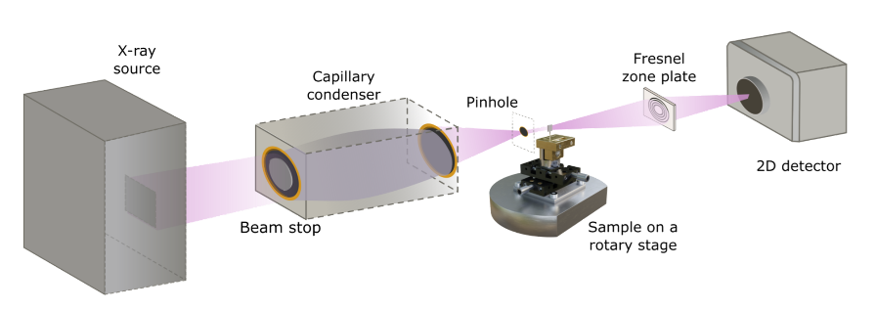
Figure 1.1: Optical beam path of state-of-the-art TXM/nano-CT tool.

In this work, two lab-based X-ray microscopes to image use case samples made of copper structures on silicon substrate were used:
(1) Xradia Inc. / Carl Zeiss AG nano-CT equipped with a rotating anode X-ray source (predominantly Cu-Kα radiation, 8.05 keV photon energy);
(2) deepXscan GmbH nano-CT equipped with a liquid metal jet X-ray source (predominantly Ga-Kα radiation, 9.25 keV photon energy).
Transmission curves for common semiconductor materials at certain thicknesses for available photon energies are shown in Figure 1.2.
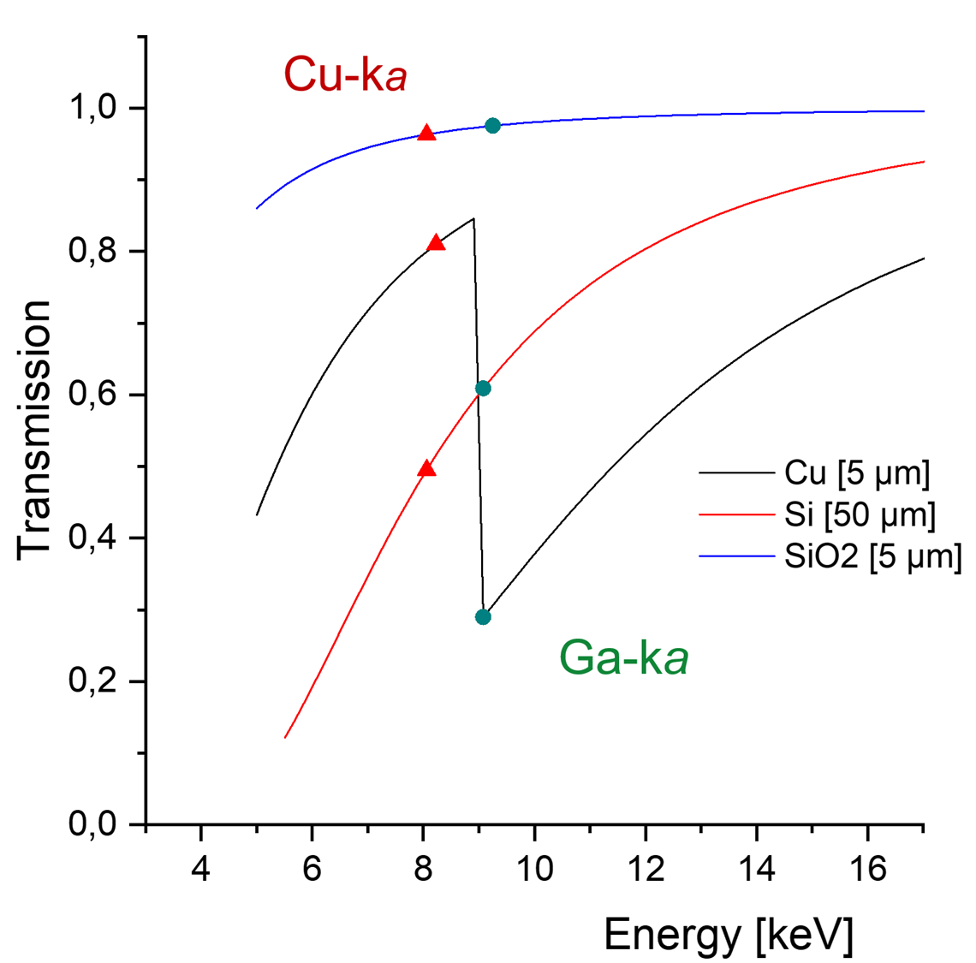
Figure 1.2: Plot of transmission curves for Cu, Si and SiO₂ at Cu-Kα and Ga-Kα radiation. Due to Cu-K edge (E = 8.98 keV), the Ga-Kα (9.25 keV) provides better contrast of Cu/Si or Cu/SiO₂ structures.

Sample description
The use case samples (WP 6) were provided by KAI GmbH, Villach, Austria. Thin copper lines with a thickness of either 5 µm or 20 µm on customized microelectronic test chips with built-in electrical heating were thermomechanically stressed by applying Joule-heating to a polysilicon heater below the structure of interest. The general layout of the chip can be seen in Figure 1.3 with the heated area marked in white. The copper pads around the heated area provide electrical contacts to the polysilicon layer and imbedded temperature sensors, necessary for adjusting the electrical power and power densities applied to the device. The silicon backing beneath the copper varies in thickness and is identified in table XX, as well as the amount of thermal stress cycles each sample experienced.
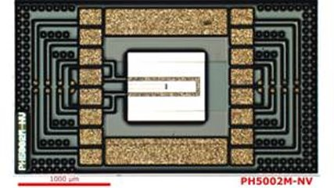
Figure 1.3 Optical microscope image of the polyheater layout.
Each sample with at least one cycle experienced the following protocol of thermomechanical stressing which is collectively names as one singular heating cycle: Heating to a bias temperature of 100 °C, application of a rapid heating pulse (200 µs in length) heating the samples to 400°C, rest time of one second in which the sample cools back to bias temperature. The first batch of the samples used to develop workflow is listed in the Table 1 below.
Sample Nr. | KAI- Nr. | Thickness Si in µm | Thickness Cu in µm | Nr. Of thermal cycling pulses
1 | P1754 | 120 | 5 | 0
2 | P1757 | 120 | 5 | 25000
3 | P1753 | 120 | 5 | 50000
4 | P1756 | 60 | 20 | 0
5 | P1758 | 60 | 20 | 25000
6 | P1755 | 60 | 20 | 50000
Table 1: Overview of the imaged samples and its parameters.

Imaging protocols
In this chapter the experimental imaging protocols and data naming protocol based on one selected use case sample are presented.

Experimental X-ray imaging workflow
General experimental workflow for TXM/nano-CT tools (Sample #3, P1753, see Table1).
- Overview: To select a sample and pre-investigate it, a 3D light microscope is used to produce a first overview over sample features and surface. The sample is arranged in the microscope, and images showing the complete sample as well as the region of interest are taken. Furthermore, a 3D topological map of the sample is produced, to improve the visibility of surface features.
- Sample mounting for X-ray microscopy: The sample is glued to a thin nail with superglue, carefully avoiding an impact to the copper lines. This nail is placed in the centre of a special clamping fixture on top of the TXM/nano-CT sample carrier. The carrier is then transferred to the positioning light microscope. An approximate area of interest is chosen with the positioning light microscope with 10x and 50x magnification, thereby simplifying the search for an adequate Region of interest (RoI) with the X-ray microscope. In the positioning light microscope, the sample is moved by defined positioning screws, which match the stage movements of the sample stage inside the X-ray microscope.
- Mark RoI: To identify the relevant RoI, gold beads with a size of 1.5 µm are attached to the sample surface using a thin hair coated in gold beads. The positioning light microscope allows a precise application with a goal to transfer only one gold bead to a selected RoI. If validation with the light microscope indicates that several beads clump together, the gold beads are removed carefully with a tissue and new ones are applied.
As soon as the RoI is sufficiently marked and positioned, the sample is transferred to the TXM/nano-CT, moving the stage inside the TXM/nano-CT to the same positions as identified with the positioning microscope. With quick radiographs, the marked RoI is identified inside the TXM/nano-CT.
- Flatfield collection: As soon as a useful RoI has been identified, the position is recorded and then the sample is moved out of the X-ray beam. Then, 30 flat field images are taken, each for the same amount of time as for the actual sample imaging (120s for 2D-mosaics per image, 180s for 3D-tomography-radiographies). These flat field images are then despeckled and averaged to create a background file that can be subtracted from all following measurements.

Acquisition of X -ray images in 2D (Mosaic maps)
- Sample pre-aligned in the TXM/nano-CT by identifying the gold marker;
- Fine focus at the selected marked structure (Figure 2.1 a);
- Flatfield collection to improve image quality (figure 2.1 b and c);
- Define scan area: The general rectangular sample area that is supposed to be scanned needs to be defined, with the coordinates of each corner written down. Out of these corners, the centre position of the area, which will be the starting point for the mosaic scan, can be calculated. In standard resolution, one Filed of View (FoV) is 65 µm by 65 µm for the Xradia nano-CT. Choosing a step size of 55 µm in both directions leads to 10 µm overlap between the images for appropriate stitching. For the test structures imaged so far, 6(x)x21(y) images have proved sufficient to image the copper lines completely. For dXs nano-CT the FoV is 68 µm x 68 µm, with corresponded step size of 57 µm (to get overlap of 15-16%). The final array consists of 5(x)x16(y).
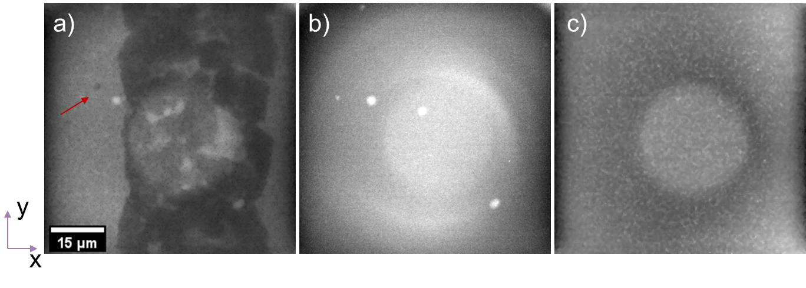
Figure 2.1: Radiographs taken at dXs TXM/nano-CT tool of a) RoI with the gold bead marker (red arrow) in focus; b) flat filed of empty beam average of 5 single radiographs; c) flat field with Si structure in the beam of 5 single radiographs. Imaging parameters: 120s/image, camera binning 8 (256 px x 256 px).

Acquisition of X-ray images for 3D (Computed tomography)
- Find the RoI marked with gold bead (Fig 2.2 a)
- Align the sample RoI to the stage rotation axis using radiographs (Fig 2.2 a and c)
- Find the focus for the selected region
- Tomography: The sample is rotated 180°, from 0° to 180°. The 0° and to 180° position shows the full surface of the chip sample (Figure 2.2 a and c), close to +90° degree position only showing the sample edge (Figure 2.2 b). This leads to a very uneven X-ray penetration distribution, the highest sample penetration at 0° and the lowest or none at the extreme angles. This effect can be reduced by cutting the sample as shown above, but it still leads to potentially unusable angles in the tomography. These extreme angles without useful sample information are removed from the finished tomography during data treatment after the measurement, resulting in a limited angle tomography.

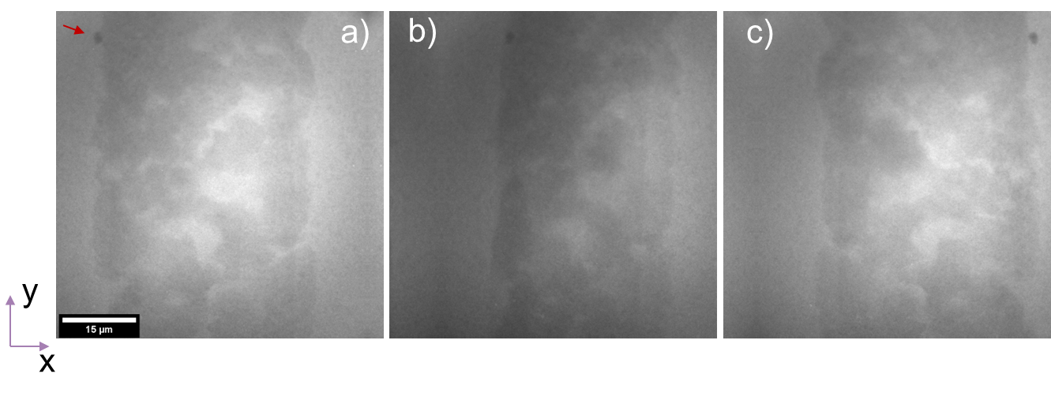
Figure 2.2: Sequence of radiographs at Xradia nano-CT: a) at 0° with marker, b) at 84° and c) at 180°.

Generated Data and naming conventions protocols

Xradia TXM/nano-CT
The Xradia data files are named by measurement sequence, type of measurement, exposure time, number of images, imaging contrast used, and relevant sample name. For one measurement series consisting of a mosaic and a tomography of the same sample, the following data entries are generated:

- 01_REF_SA_b1_120s_30x.txrm
- 01: first measurement. If the reference file was not taken specifically in this line of experiment, but at an earlier date with comparable conditions, the assigned number is 00, and the next data entry will start with 01 irrespectively of the content
- SA: absorption contrast
- B1: Binning 1 (1024 x 1024 px)
- 120s: Illumination time for each x-ray image radiography.
- 30x: number of radiographies taken for this data set
- 01_REF_SA_b1_120s_30x_Despeckle-Ave.xrm
- Despeckled and averaged single image generated from the previous flat field measurements. Will be subtracted from further images as background correction.
- 02_fs.txrm
- Focal series used to determine location of focal point
- 03_mosaic_P1777_500cycles_b4_6x21_120s.txrm
- Mosaic of defined region
- P177_500cycles: relevant sample info for identification
- B4: binning 4 (256 x 256 px)
- 6x21: number of images in x and y direction in the mosaic
- 120s: illumination time
- 04_tt.txrm
- Test tomography to ensure complete visibility of the sample during the 180° rotation, usually with only 3-5 different angles
- 05_TOMO_SA_b1_180s_801x.txrm
- Tomography of RoI for full 180° rotation
- SA: absorption contrast
- B1: binning 1 (1024 x 1024 px)
- 180s: illumination time at each angle
- 801x: 801 images taken, spaced evenly over the 180° rotation range, so one image every 0.225°

More data can be generated and saved in between or after these steps, if necessary for the experiment, but it always follows the described naming scheme.

deepXscan TXM/nano-CT
The deepXscan data files of single or successive measurements that are created and saved in a folder named according to the date (YYYY_MM_DD-hhmmss_) and the type of measurement, exposure time, number of images, image contrast used and the respective sample name. This main folder contains the following data: tif (captured images), txt, index (positions and tool settings). Based on the agreement with the users within this project, the naming conventions of the experiments are similar to the Xradia tool as described above, with the addition of the only data before each file instead of numbering.
Example: 2023_11_20-165936_mosaic_P1777_500cycles_b8_6x21_120s (folder).
The difference of camera binning as follow: Binning 1 (2048 X 2048 px), Binning 2 (1024 x 1024 px) and so forth.
Such an approach to data naming makes it practicable to understand the experimental workflow and to share the data.

Data analysis workflow
In this chapter the data analysis workflow for TXM/nano-CT tools (based on one selected use case sample Sample #2, P1757, Sample #3, P1753, see Table1) are presented.

2D image treatment
All images are flatfield-corrected with the Xradia software XMController for Xradia TXM/nano-CT, and all further image data treatments are performed using ImageJ. deepXscan TXM/nano-CT treated only using ImageJ.
For 2D-mosaics, following workflow for data treatment has been established:
Flat field creation and subtraction: From the collected array for mosaic (e.g 6(x) x 21(y)), only single radiographs with silicon backing area are identified. Using the Fiji software – an extension of the image processing software ImageJ - these selected Si-backing-images are all opened at the same time and converted into a stack. Using the z-projection function, the images are averaged, and the resulting average image is saved. Then, from each image in the stack the averaged Si-backing is subtracted using the image calculator. The resulting stack of images with subtracted backing are then saved as image sequence in a separate subfolder inside the sample specific folder.
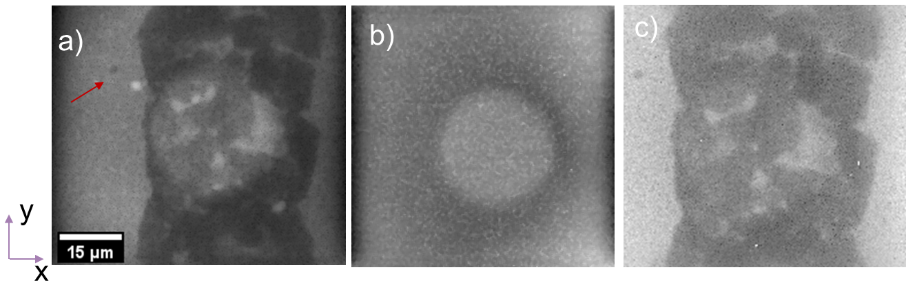
Figure 3.1: Radiographs taken at dXs TXM/nano-CT tool of a) Raw radiograph of Cu structures in focus and gold bead marker (red arrow); flat field with Si structure in the beam of 5 single radiographs (Z- projection); c) Result of Divided raw radiograph (a) by a flat filed (b). Imaging parameters: 120s/image, camera binning 8 (256 px x 256 px). Sample #3, P1753 (Table 1).
The backing-corrected mosaic images are then stitched with the stitching plug-in. For this, stitching type grid/collection stitching is used. The mosaic images are numbered from top left to bottom right; therefore row-by-row and right&down are the chosen stitching directions. Then, the grid size is entered (usually 6 in x-direction and 21 in y-direction) with an overlap of 16%. These 16% correspond to a 10 µm overlap for a 65 µm FoV (Xradia) or 11 µm overlap for a 68 µm FoV (dXs) which are the chosen parameters for the initial scan. Then directory and file names of the Si-backing and flatfield corrected mosaic images are chosen, and the selected fusion method is linear blending to allow for a smooth transition between neighbouring images. The following parameters are chosen (more details for the method can be found in the respective ImageJ wiki entry for image stitching): regression threshold: 0.1, Max/Avg Displacement Threshold 0.5, Absolute displacement threshold 0.5.
The stitched image is displayed, and contrast and brightness are adjusted to maximize the feature visibility. Furthermore, to enable correct scale bars, a single image from the original image sequence of mosaic images is opened and its details are examined. Based on the applied camera binning, the resulted image is scaled via adding manually known values by running the set scale function. Usually camera binning 4 (Xradia) and camera binning 8 (dXs) with 256 px x 256 px provides ca. 3.8500 px per 1 µm. As last step the scale bar tool can be used to apply an adequate scale bar to the image.
In Figure 3.2 the final mosaics based on both TXM/nano-CT are shown.
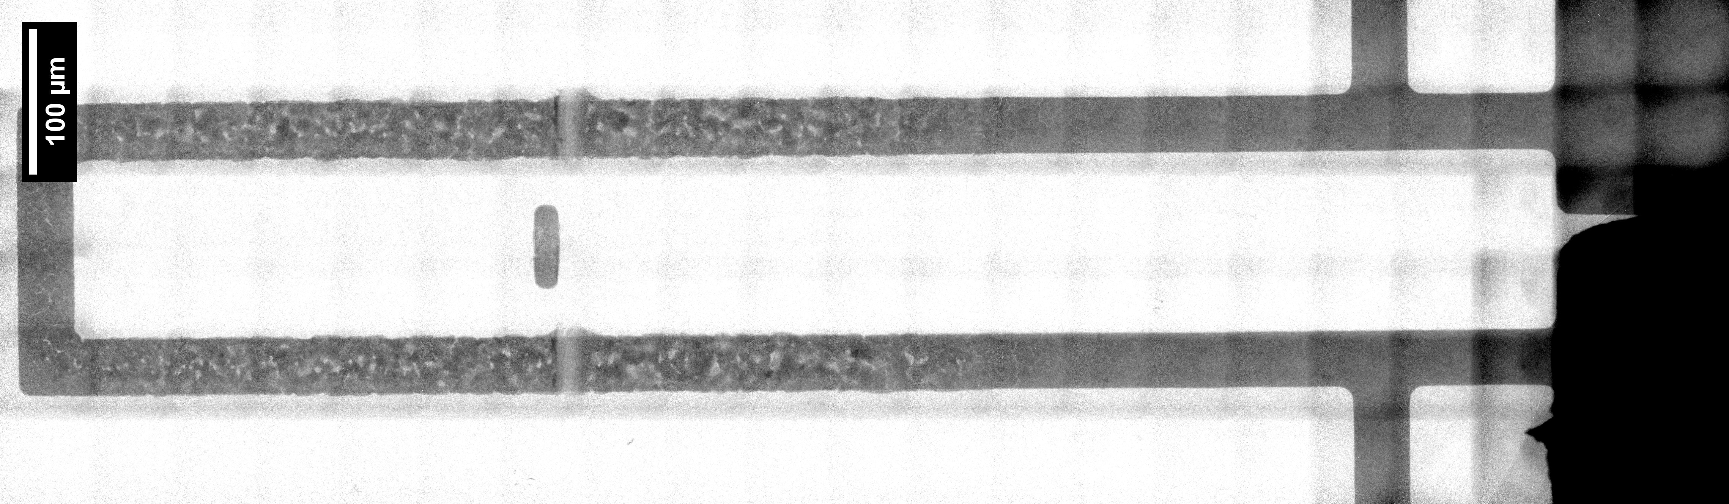
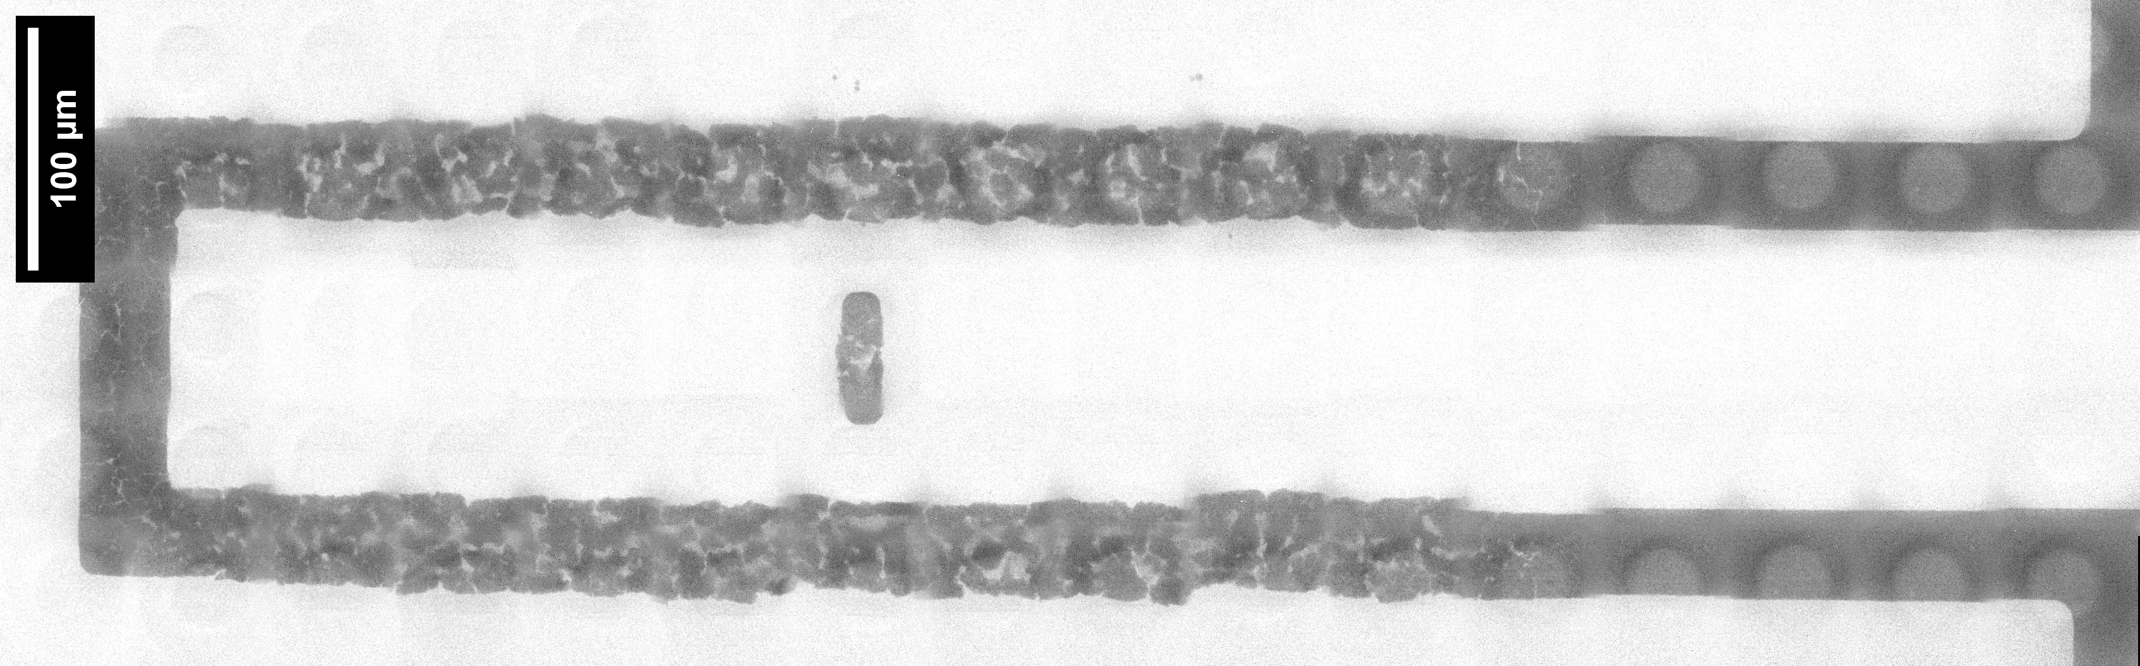
Figure 3.2: Resulted mosaics of polyesters achieved in TXM/nano-CT tools: Upper based on Xradia sample #2, P1757; Lower based on deepXscan, sample #3, P1753.

3D-image treatment
This example is showing the proof-of-concept for 3D imaging of the use case (Sample #3, P1753) based on the Xradia TXM/nano-CT tool. All images are flatfield-corrected with the Xradia software XMController. All further image data treatments are performed using ImageJ.
Radiographs alignment: The selected tomography file is opened using the XRM-file option in Fiji. Then the image is minimized to exclusively the area of the gold bead, and the remove outliers function with a threshold of 500 is applied, and subsequently the function adding a Gaussian blur with at sigma between 1 and 3. From the acquired data set each radiograph is aligned using the gold bead by plugin “bead aligner” based on XY method taking of bead across all images and fitting to the corresponding sinogram over a certain angle range, e.g 180 °. If the fit and the sinogram seem sufficient, the TXRM file is updated, thereby reducing imaging errors due to thermal shifts in the microscope. The shifts are saved in a separate data entry and the bead aligner is closed.
Reconstruction: Then the updated TXRM is used for reconstruction with the reconstruction software of the users’ choice, e.g. Tomo3D. For this, the TXRM data is flipped, inverted and resized to 8bit and then transferred to a Tomo3D program folder. Furthermore, a .txt file containing the used rotation angles is added to the folder. Then, the TXRM file is moved on top of the Tomo3D.exe, thereby producing a reconstructed tomography.
The reconstructed file can then again be opened in ImageJ, where adjusting contrast and brightness as well as the general threshold can be used to reveal the inner structure of the sample. Furthermore, different orthogonal slices can be made through the 3D image, allowing for easy visibility of different cross-sections through the material in horizontal and vertical direction. A 3D rotating view can also be recorded and saved as a movie. A scale bar is added in the same manner as described above.
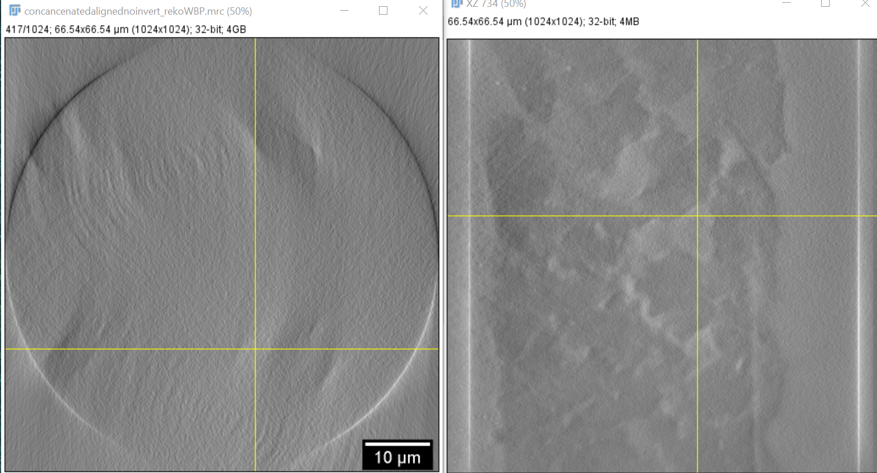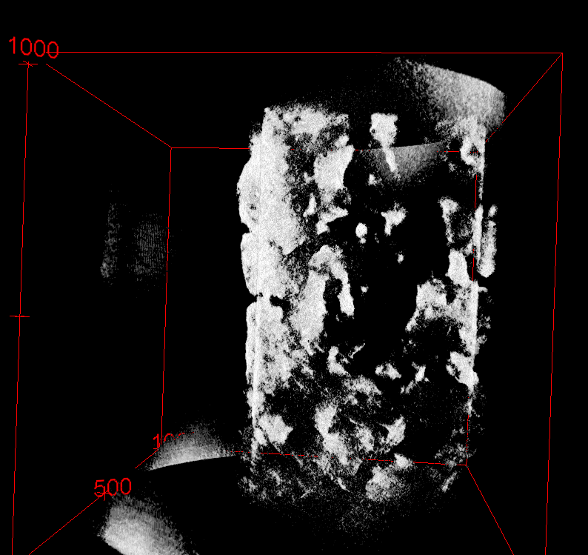
Figure 3.3: Reconstructed data set on right is orthogonal views (XZ, XY) and on the left 3D view based on ImageJ.

Outlook
The developed experimental workflow and imaging protocol using laboratory-based X-ray microscopy and computed tomography technique at several photon energies enables the investigation of the copper material degradation process in 2D and 3D. This characterisation method promises a comprehensive correlative investigation with increased image contrast, improved data quality thus provides essential input to copper degradation in nanoscale.
The used settings of X-ray microscopes are based on absorption contrast at standard resolution with a field of view (FoV) of 65 µm x 65 µm and 68 µm x 68 µm, providing sub 150 nm resolution. Next, imaging in high-resolution mode with a different imaging lens (Fresnel zone plate) is planned. The imaging protocol will be adapted accordingly so that a resolution of 50 nm can possibly be achieved.
The 3D imaging of the use case examples from WP6 with improved sample geometry is planned on the basis of the results of the proof of concept. Because of the inherent 2D-nature of the sample chips, a reduction of sample width to only the centre copper line is one of the ways to substantially improve the quality and reproducibility of the 3D imaging. To test this, a wafer saw was used to cut the two 50000 cycles samples (5µm and 20µm) to a smaller width planned for tomography provided by KAI and planned to be imaged (Figure 4.1). The thin copper lines already showed severe degradation after 25000 cycles. Therefore, new pre-cycled samples with lower cycling numbers will be provided and cut for tomography by KAI.
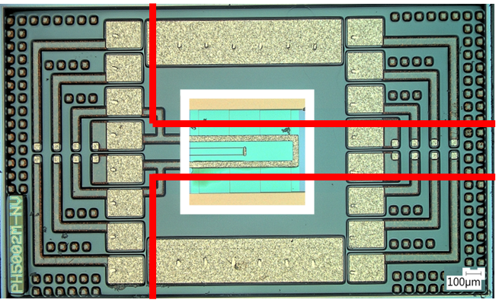
Figure 4.1:Optical microscopy image of polyheater design. Red lines showing area to be cut out.

The developed workflow for 2D and 3D imaging will be further developed to improve the quality of the X-ray images and to understand the information we gain from them. With this more solid experimental and data analytical workflow that applies to further use cases.
A coherent data management structure between the Xradia microscope and the dXs microscope will be established to allow for easy comparability between the two tools. Within this task it is planned a proof-of-concept imaging of CuSn-based intermetallics and GaN nanopipes.

Summary and Conclusion
The main goal of T3.1 is to set up robust and validated protocols for lab-based Transmission X-ray Microscopy and nano-Computed Tomography (TXM/nano-CT) with multiple photon energies, targeting on advanced 3D high resolution imaging and analysis for use case samples from WP6 (polyheaters). The validation of the experimental workflow and the data analysis for 2D large area to study copper degradation at nanoscale is done based on two lab-based transmission X-ray microscopy and computed tomography techniques utilising photon energies of 8.05 keV and 9.25 keV. Since the Cu-K edge (E = 8.98 keV) is slightly below the Ga-Kα line (9.25 keV), it provides better contrast of Cu/Si or Cu/SiO₂ structures.
The proof of concept for 3D imaging provides first inside of copper degradation in 3D. It will be optimised in future with an improved nano-CT set up. The results will be correlated to the different cycling parameters of polyheaters.

List of Abbreviations
Abbreviation | Translation
TXM/nano-CT | Transmission X-ray Microscopy/nano- computed tomography
RoI | Region of interest
FoV | Field of View
FZP | Fresnel Zone Plate

